Please proceed the following steps to run this demo:

1.   Set the following parameters in Exp3.m before executing it.

PIE_face_path (path to the cropped face images)

person (number of faces to be synthesized per image)

pose_distribution (IDs of pose in PIE)

illuminated_distribution (IDs of illumination condition in PIE)

%%%ORIENTATION PARAMETER

pdmax=25*(pi/180);

pdmin=-25*(pi/180);

%%%FACIAL SIZE

smax=0.2;

smin=0.1

2.   Execute Exp3.m, and input the number of background image.

[https://sites.google.com/site/avlabbenchmark/_/rsrc/1362562095038/face-synthesis/ScreenClip%20%5B25%5D.png?height=38&width=400](https://sites.google.com/site/avlabbenchmark/face-synthesis/ScreenClip%20%5B25%5D.png?attredirects=0)

     3.   Manually annotate the centers of faces to be synthesized.

[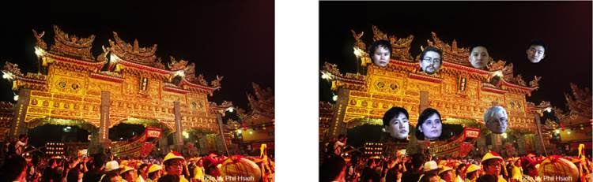](https://sites.google.com/site/avlabbenchmark/face-synthesis/%E5%9C%96%E7%89%875.jpg?attredirects=0)

     4.   The synthesized images and corresponding face masks will be automatically saved in the ”result” folder. The file name will be saved as ”syn_X.jpg” and “gd_X.jpg”, where X is the background image    number.

[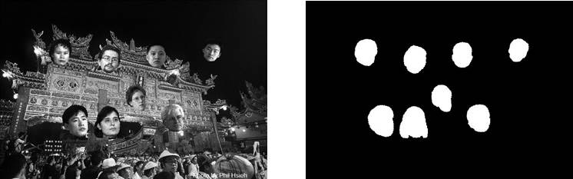](https://sites.google.com/site/avlabbenchmark/face-synthesis/%E5%9C%96%E7%89%876.jpg?attredirects=0)